DAY_03 ASSIGNMENT

1.grep ‘Linux’ ‘Desktop/f1’:

It will display where Linux is present and it is case sensitive.

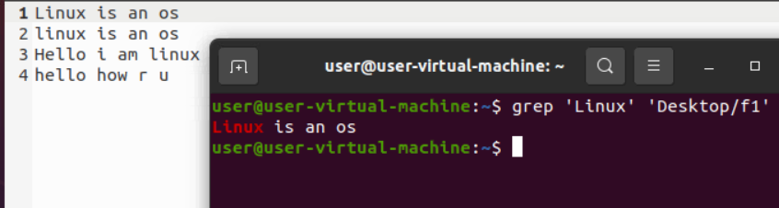

2.grep –i ‘linux’ ‘Desktop/f1’:

It will display where the linux is present in the data and it is ignore the case sensitive.

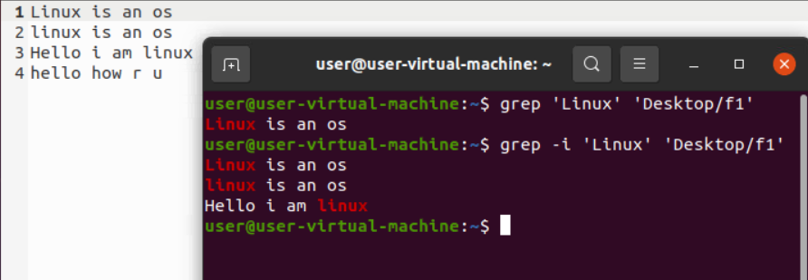

3. grep –c ‘linux’ ‘Desktop/f1’:

It will count the lines where linux is present at 1st .

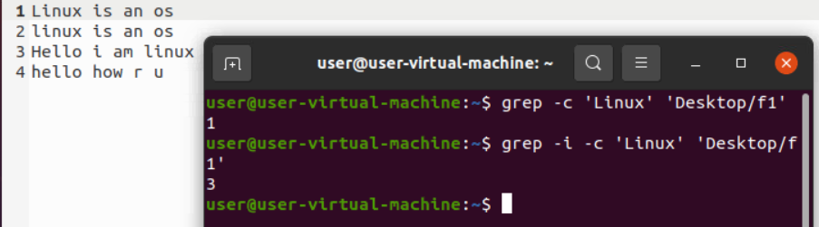

4. grep –w ‘linux’ ‘Desktop/f1’:

By using –w command to see the full line of where linux is present.

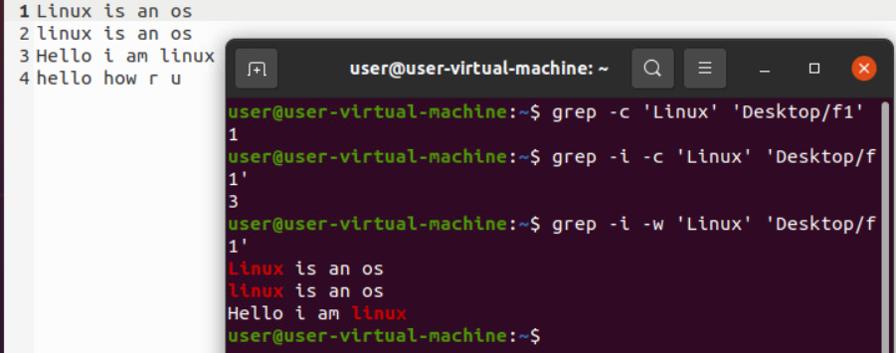

5. grep –0 ‘linux’ ‘Desktop/f1’:

It Displays the matching pattern.

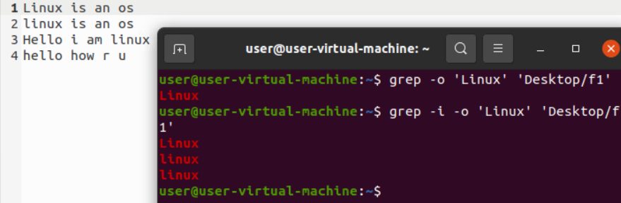

6. grep –0 -w ‘linux’ ‘Desktop/f1’:

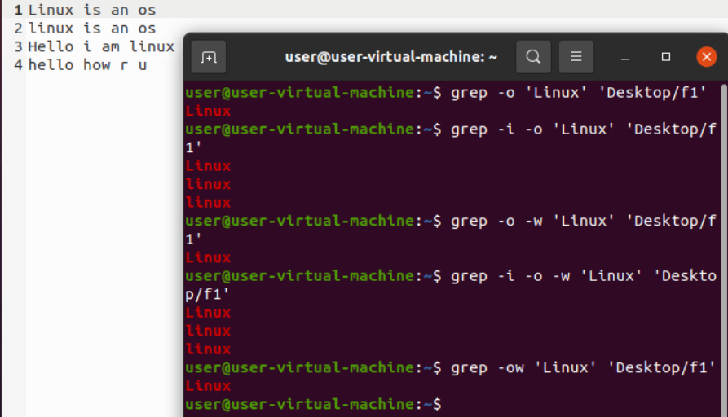

7. grep –n ‘linux’ ‘Desktop/f1’:

It prints the line number.

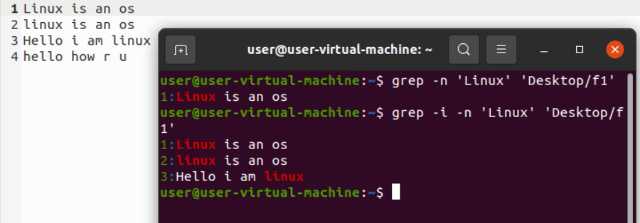

8. grep –v ‘linux’ ‘Desktop/f1’:

It will display without particular word here linux.

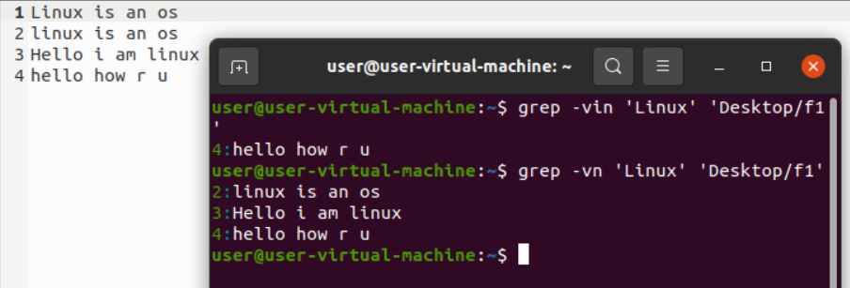

9. grep ‘˄linux’ ‘Desktop/f1’:

It will display the starting word as linux.

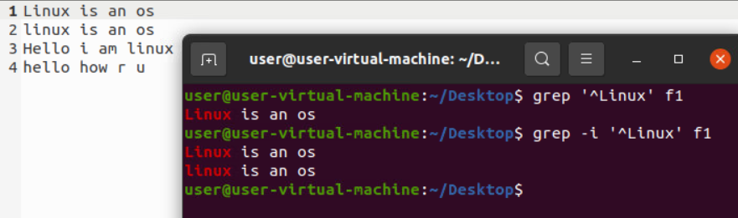

10. grep -in ‘os$’ f1:

It will display os present in the last line.

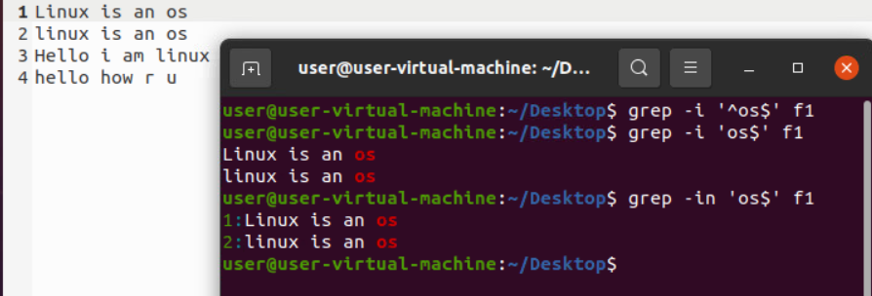

11. grep -E ‘^hello.*hello$’ f1:

It will display first and last as same.

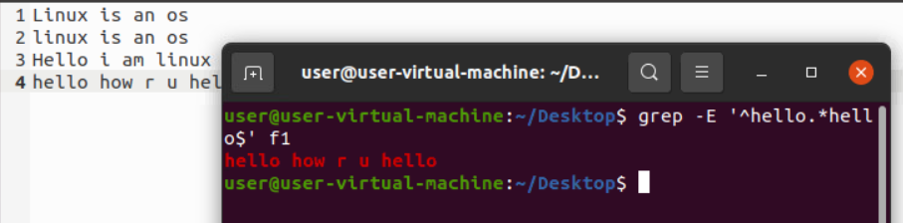

12.grep –ni _E “^os.* os$” f1

It displays start with os and end with os.

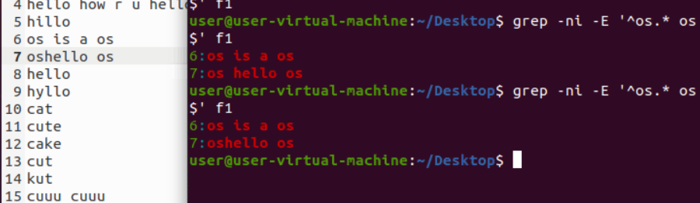

13. grep –ni _E “^os .* os$” f1

It displays like this

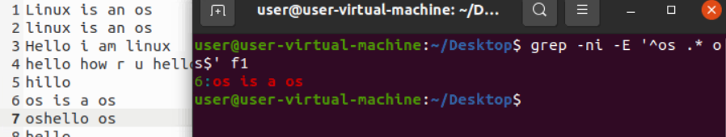

14.grep –ni –E “^h..p$” f1

It displays first h and last p inbetwween based on dots.

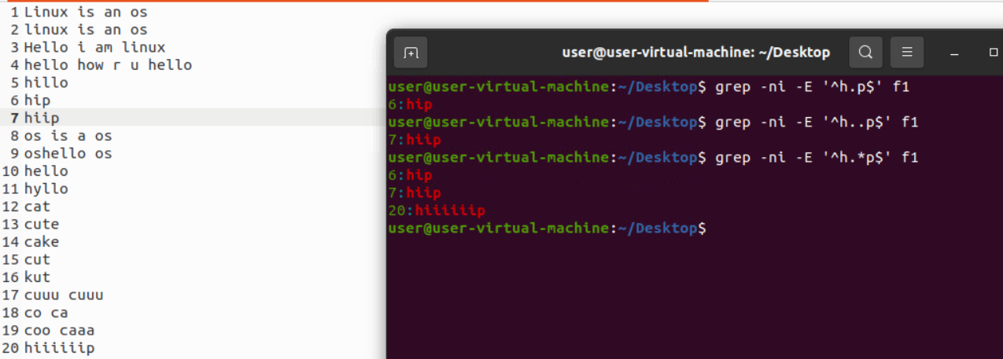

15. grep –ni –E “^h[i]p$” f1

It displays start with h and end with p in brackets I,o what we give it will display

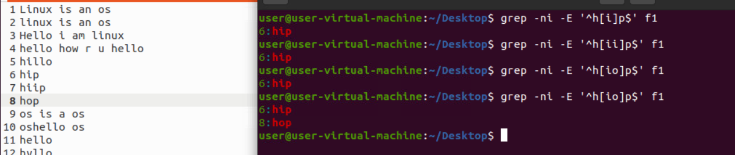

16. grep –ni –E “^hi+p$” f1

It display hiiiiip,hip,hip.

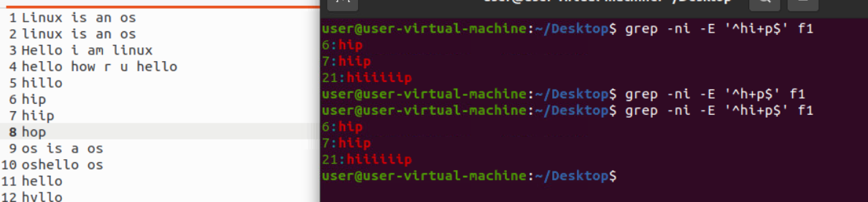

17. grep –ni –E “^c. .a$” f1

It displays 5 characters start with c end with a.

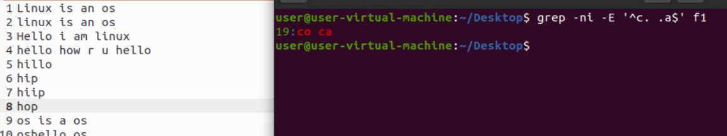

18. grep –ni –E “^h[^i].*o$” f1

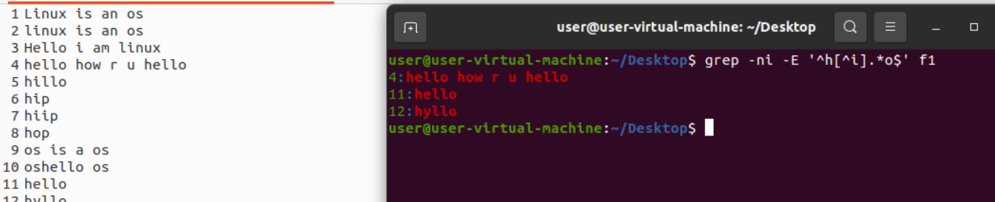

19 .grep –E –I ‘^c.* u$’ f1

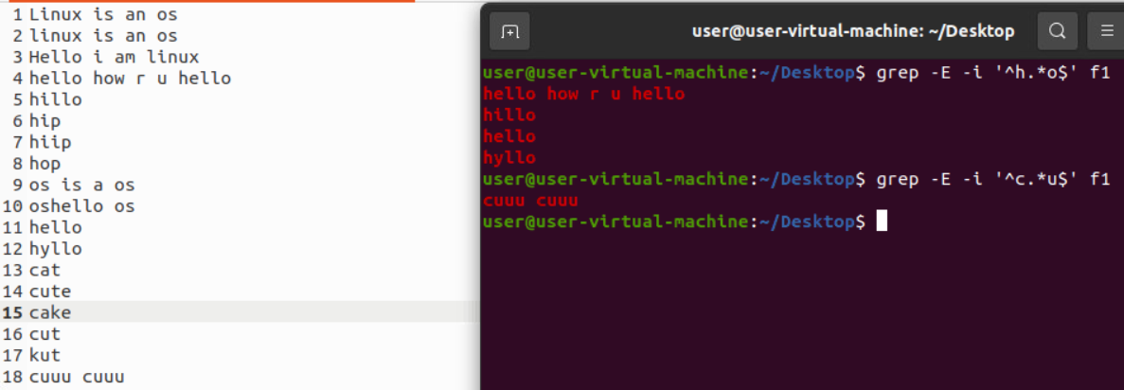

20.grep –c ‘When’ f2

It counts how many times When is present.

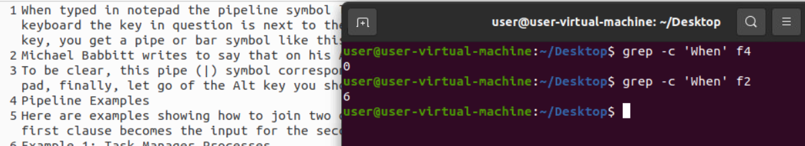

**CUT commands:**

1.cut –c 1 f1

This is used to display the 1st column.

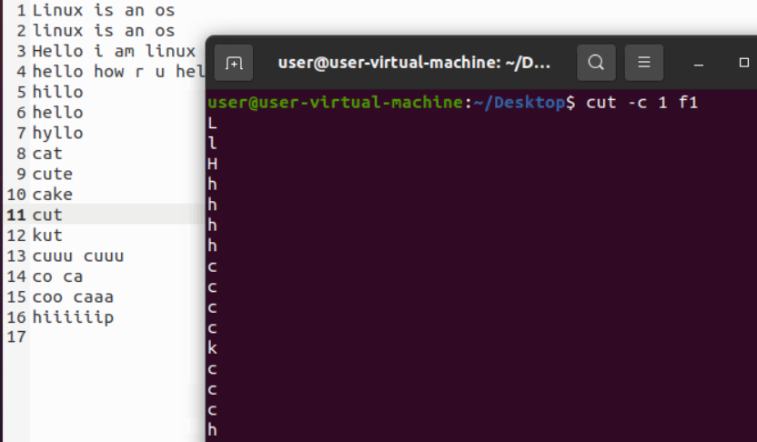

2.cut –c 1-4 f1

It displays 1-4 columns

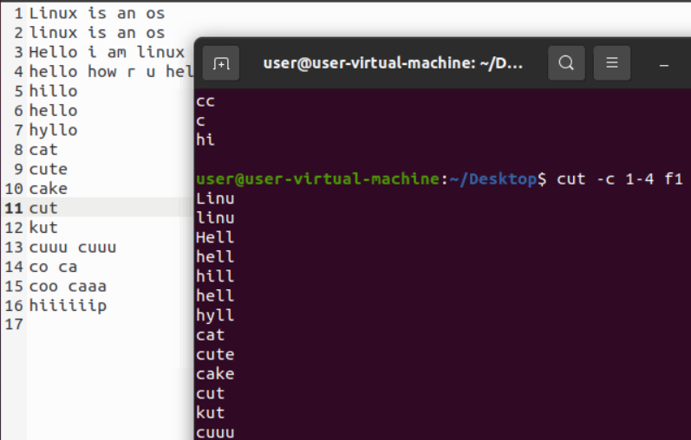

3.cut –c -5 f1

It displays from 1st to 5

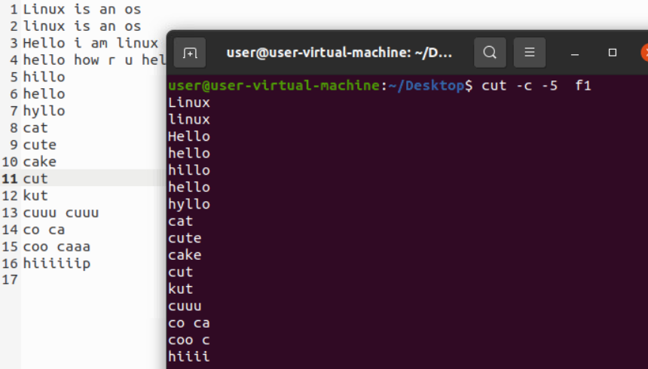

4.cut –b 1-5 f1

It displays 1-5 bytes

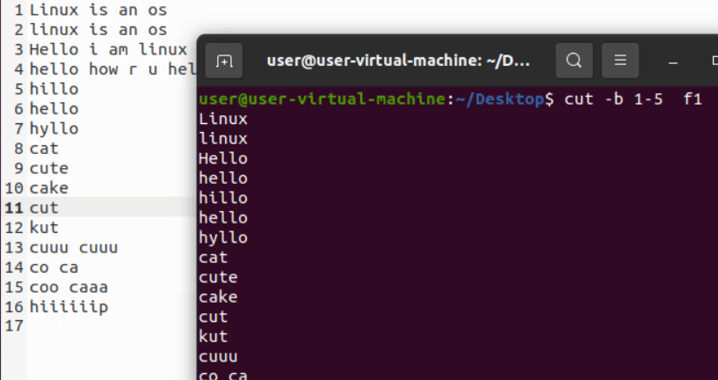

5.cut –f 1 f1

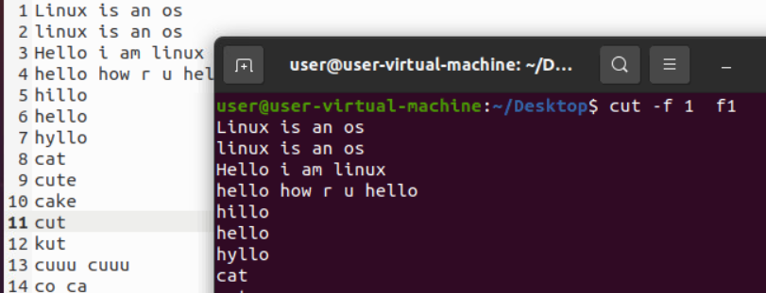

6.cut –d ‘s’ –f 1 f1

It cuts s to next words

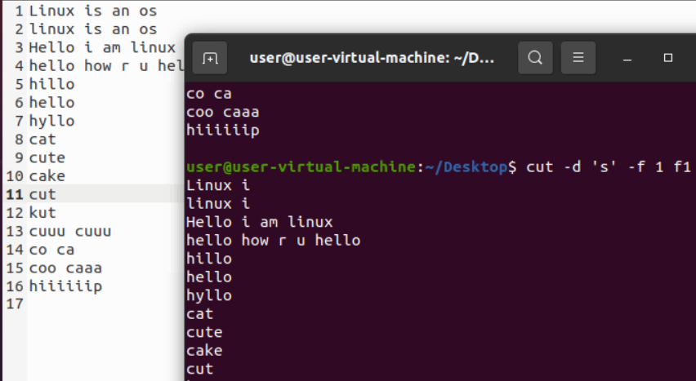

7.cut –complement –d ‘ ‘ –f 5- f4

It displays except 5 remaining all.

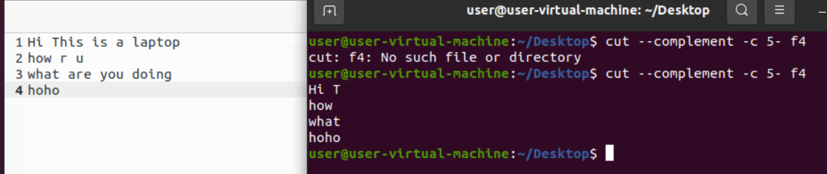

8.cut --complement –d ‘ ‘ –f 1 f4 –output-delimiter=’+’

It displays the + in delimiter place

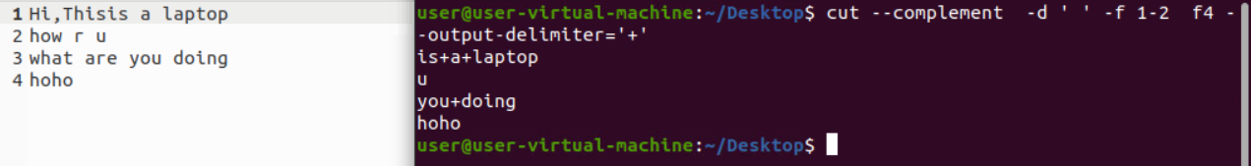

9.cut –d ‘ ‘ –f 1 f4 |sort –r

It sorting the order

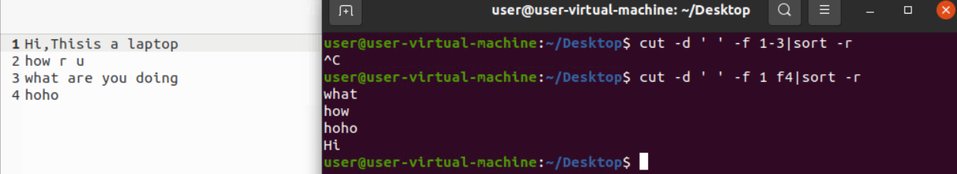

10.cat f4|cut –d

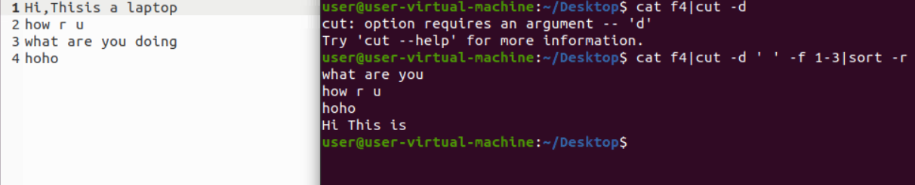

TR commands:

1.cat f4|tr ‘[a-z]’ ‘[A-Z]’

It displays lower to upper.

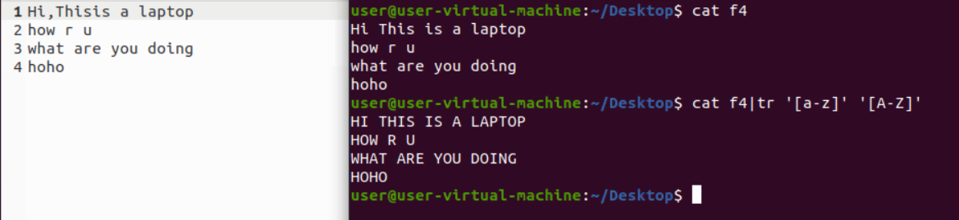

2.cat f4|tr ‘[:space:]’ ‘\n’

It displays in next line.

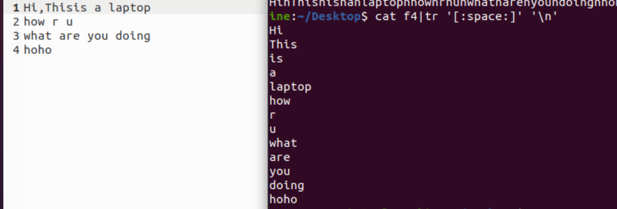

3.cat f4|tr ‘[H]’ ‘[0]’

It shows o in h place.

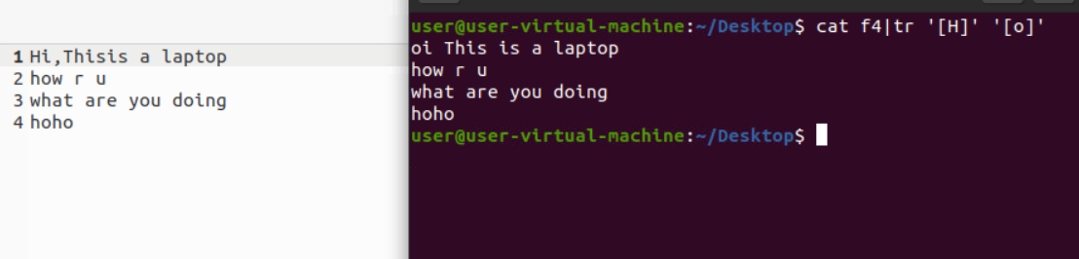

4.cat f4|tr –d ‘[a-i]’

It shows only except a-I remaining it displays.

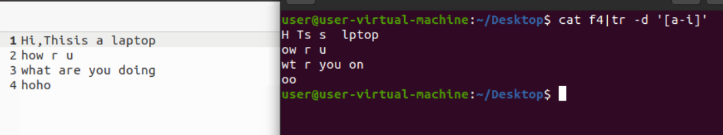

5.cat f4|tr –d ‘[:upper:]’

It deletes the upper cases it shows remaining.

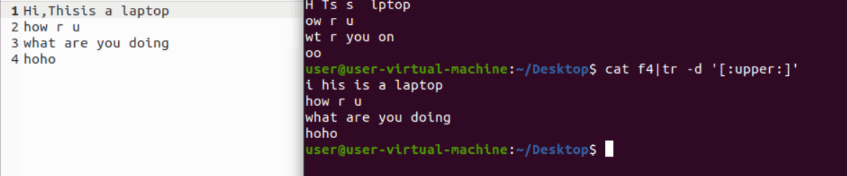

More commands:

1.more f2

It display all the data

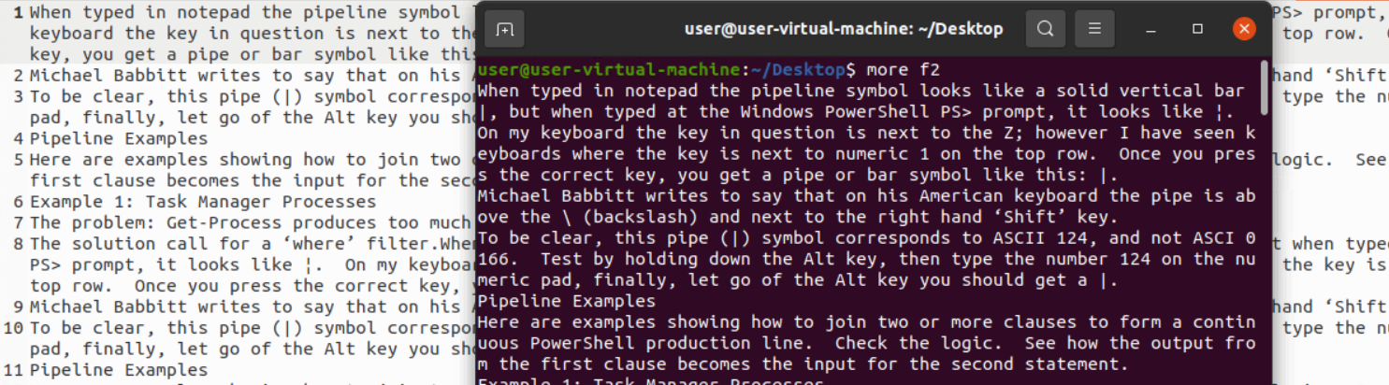

2.more –d f2

 Use this command in order to help the user to navigate

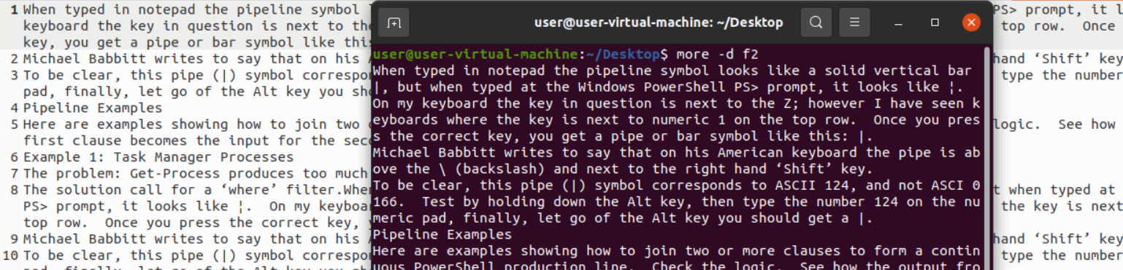

3.more –p f2

This option clears the screen and then displays the text.

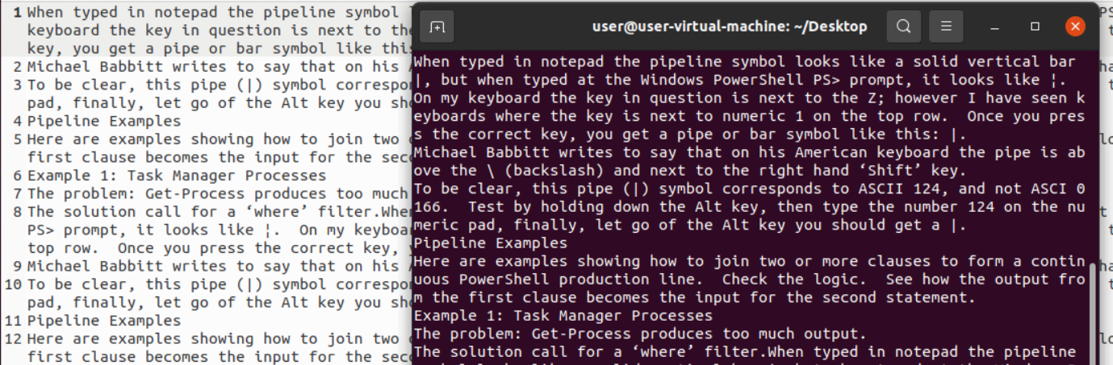

4.more –c f2

 This command is used to display the pages on the same area by overlapping the previously displayed text.

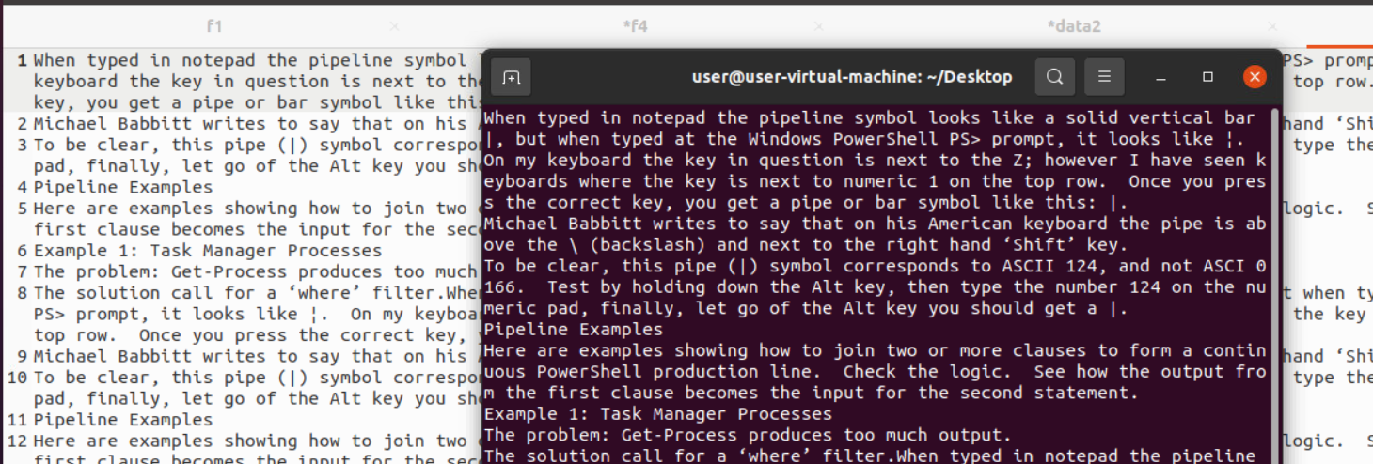

5.more –s f2

This option squeezes multiple blank lines into one single blank line.

